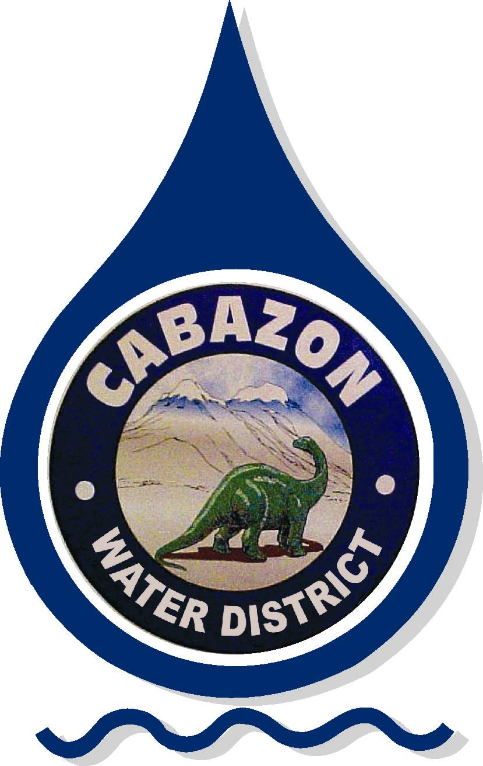

Cabazon Water District
14618 Broadway Street • P.O. Box 297
Cabazon, California 92230

SPECIAL BOARD MEETING

AGENDA

Meeting Location:
Cabazon Water District Office
14618 Broadway Street
Cabazon, California 92230

Meeting Date:
July 5, 2018 – 10:00 AM

CALL TO ORDER
PLEDGE OF ALLEGIANCE
REMEMBRANCE OF OUR SERVICE MEN AND WOMEN
ROLL CALL
CONSENT CALENDAR

All matters in this category are considered to be consistent with the Board/District goals, District Policies and Regulations adopted and/or approved by the Board of Directors, and will be enacted in one motion. There will be no separate discussion of these items. If discussion is required, items may be removed from the consent calendar and will be considered separately.

- Approval of - None
- Warrants – None
- Awards of Contracts – None

UPDATES

CLOSED SESSION

- CONFERENCE WITH LABOR NEGOTIATORS:
Agency Representatives: (Calvin Louie, Ellie Lemus, Joe Ortiz) Employee Organization: (SEIU)

OPEN SESSION
OLD BUSINESS
NEW BUSINESS
PUBLIC COMMENTS

Any person may address the Board of Directors at this time on any matter within the subject matter jurisdiction of the Cabazon Water District that is not listed on the agenda; however, any matter that requires action will be referred to staff for investigation and reported at a subsequent Board of Directors meeting. The Board of Directors is prohibited by law from discussing or taking immediate action on items during this public comment period. To comment on specific agenda items, please advise the Board secretary prior to the meeting. Each public comment will be limited to three (3) minutes. Individuals may not give their time away to another spokesperson. After two (2) minutes, the speaker will be notified that he/she has one (1) minute remaining. AB 1234 ORAL REPORTS (Gov. Code Sec. 53232.3(d))

GENERAL MANAGER/BOARD COMMENTS

- Future Agenda Items

The Board Chair or the majority of the Board may direct staff to investigate and report back to an individual(s) and the Board on matters suggested or direct the General Manager/Board Secretary to place the matter on a future Board meeting.

- Suggested agenda items from the Public.
- Suggested agenda items from Management.
- Suggested agenda items from Board Members.

- Management Comments

Staff members may speak on items of information not requiring comment or discussion to the Board and public. Topics which may be included on a future meeting agenda may be presented but cannot be discussed. (3 minutes)

- Board Member Comments

Board members may speak on items of information not requiring comment or discussion to the Board and public. (3 minutes)

MISCELLANEOUS

- Future Board Items/Next Board Meeting Date(s)

- Finance & Audit Workshop – Tuesday – July 17, 2018, 5:00 pm
- Regular Board Meeting – Tuesday – July 17, 2018, 6:00 pm
- Personnel Committee – None
- San Gorgonio Pass Regional Water Alliance – Alliance Meeting – June 27, 2018, 5:00 pm

ADJOURNMENT
ADA Compliance Issues

In compliance with the Americans with Disabilities Act & Government Code Section 54954.2, if special assistance is needed to participate in a Board meeting, please contact the Clerk of the Board at (951) 849-4442. Notification of at least 48 hours prior to meeting time will assist staff in assuring that reasonable arrangements can be made to provide access.

